Proceedings of the 39th National Conference on Mechanical Engineering of CSME: Guidelines for Long Abstract Preparation

Author Name¹*, Author Name²
¹First Author’s English Affiliation
²Second Author’s English Affiliation
（MOSTXX-XXXX-XXXX-XX）
＊Email: Corresponding author’s email address

The 39th National Conference on Mechanical Engineering of CSME will be hosted by National United University. It will be held in Miaoli City on December 2 and 3, 2022. To assist participants in preparing their manuscripts for the conference proceedings, this Word template is provided. The length of each long abstract should not exceed 2 pages and briefly to describe the following parts in order: research motivation, research method, results, and conclusion, etc. Manuscripts submitted should strictly follow the format of this template. Only manuscripts in the PDF format with no page numbers are acceptable and manuscripts should be submitted via the official website of the 39th National Conference of CSME, http://csme2022.nuu.edu.tw/. The size of the PDF file should be less than 3 MB. 【Font Setting】The acceptable fonts are Times New Roman and Symbol. The title of the article should be in 14-point boldface type. Capitalize the first letter of nouns, pronouns, verbs, adjectives, and adverbs; do not capitalize articles, coordinate conjunctions, or prepositions (unless the title begins with such a word). Authors’ names and affiliations are to be centered beneath the title and in 12-point non-boldface type. Subtitles should be in 11-point and boldface. Type your main text in 10-point. All paragraphs should be indented by 0.9 cm. 【Margin Setting】The paper size is A4 (21 cm by 29.7 cm) with the following margins: upper 3 cm, lower 3 cm, left 2 cm, and right 2 cm. These margin settings should be followed under all circumstances. 【Figures and Tables】Figures and tables can be either placed at the end of paper as demonstrated in this template, or inserted within the running text. Captions of figures and tables should be in 10-point Times New Roman. The alignment of the caption can be either centered or justified, depending on the width of the figure. 【Equations】Equations should be centered aligned and numbered.
(1)
【References】List and number all bibliographical references at the end of your paper. When referenced in the text, enclose the citation number in square brackets. Formats are given below for your reference for journal paper [1], book [2], conference paper [3], thesis [4], and webpage [5]. We look forward to seeing you at the conference. If you have any problem or question in preparing or submitting your manuscript, please feel free to contact us via the following e-mail address: csme2022@nuu.edu.tw.

Keywords: A list of 2-4 keywords.

Acknowledgements
This work is funded by Ministry of Science and Technology under grant MOST-000-0000-E-000-MY3.

References
- S. L. Chiu and T. H. Lin, “Breakup of Compound Liquid Jets under Periodic Excitation at Small Core-to-Shell Mass Ratios,” Journal of the Chinese Institute of Engineers, Vol. 31, No. 1, pp. 21-28, 2008.
- H. S. Yan, Creative Design of Mechanical Devices, Springer, Singapore, pp. 166-188 (1998).
- S. Vechet, J. Krejsa and K. S. Chen, “AGVs mission control support in smart factories by decision networks”, Proceedings of the 2020 19th International Conference on Mechatronics - Mechatronika (ME 2020), Prague, Czech Republic (2020).
- 鄧予安, "銅與環氧樹脂界面受循環負載下之疲勞裂紋成長", 國立成功大學機械工程學系碩士論文, 台灣 (2003).
- http://csme2022.nuu.edu.tw/

Figures and Tables
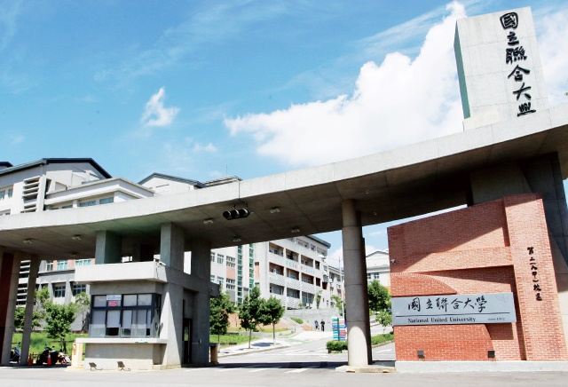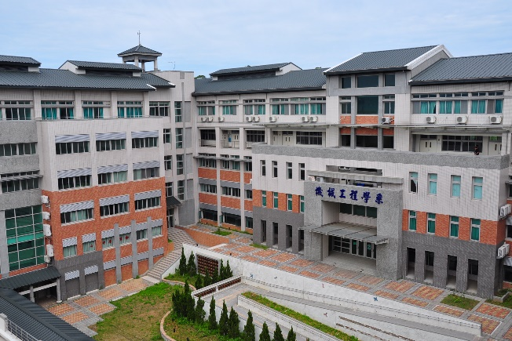
Fig. 1 The 39th National Conference on Mechanical Engineering of CSME will be held in Miaoli City on December 2, 3, 2022.

Table 1 Important dates for the 39th National Conference on Mechanical Engineering of CSME.
Draft Paper Submission Deadline | 2022.09.26
Notification of Acceptance | 2022.10.17
Final Paper Submission Deadline | 2022.10.21
Online Payment Deadline | 2022.10.31

