Preparation of the Extended Abstract for 2022 International Conference on Machining, Materials and Mechanical Technologies (2022 IC3MT) using Arial 14
FULL First Author^{1, a *}, FULL Second Author^{2,b} and FULL Last Author^{3,c}
¹Full address of first author, including country
²Full address of second author, including country
³List all distinct addresses in the same way
ªemail, ^{b}email, ^{c}email
* Please mark the corresponding author with an asterisk
Keywords: International conference on progress machining technology, extended abstract formatting guidelines, deadline
For the rest of the paper, please use Times Roman (Times New Roman) 12
Abstract. This is the template for preparing an extended abstract for 2022 IC3MT: the 4th conference on Machining, Materials and Mechanical Technologies, 2022. The conference will be held at the Main Campus II of National Taiwan Normal University, Taipei, August 19 - 23, 2022. The contributors should write their abstract with keywords according to the paper formatting guidelines and save it into MS-WORD format. Abstracts should be submitted via the IC3MT website and marked with the relevant themes. The deadline for abstract submission is April 8, 2022. Authors of accepted abstracts are required to prepare an Extended Abstract or a Full Paper according to a specified camera-ready format. The submitted extended abstracts and full papers will be reviewed, and only the outstanding full papers are expected to be published in the journal (Trans Tech Publications) further. The format of the extended abstract is as follows.
All manuscripts must be in English, also the table and figure texts; otherwise, we cannot accept your paper. Please make the page settings of your word processor to A4 format (21 x 29.7 cm); with the margins: bottom 1.5 cm and top 2.5 cm, right/left margins must be 2 cm. Do not number the pages of the paper. The contributors should follow the instruction on the web page http://ic3mt2022.conf.tw and upload the file.
The extended abstract should not exceed two pages, including tables, figures, equations, and references. The extended abstract should describe the objectives, the methodology, and the main conclusions of the paper. The tables and figures should be cited, and the equations should be inserted in the text.
Tables. Tables (refer with: Table 1, Table 2, etc.) should be presented as part of the text, but in such a way as to avoid confusion with the text. A descriptive title should be placed above each table.
Figures. Figures (refer with: Fig. 1, Fig. 2, etc.) should be presented as part of the text, leaving enough space so that the caption will not be confused with the text. The caption should be below the figure.
Equations. Equations (refer with: Eq. 1, Eq. 2, etc.) should be indented 5 mm. There should be one line of space above the equation and one line below it before the text continues. The equations have to be numbered sequentially, and the number put in parentheses at the right-hand edge of the text. The use of Microsoft Equation is allowed.
c² = a² + b² (1)
(2)
Citations. References should be included. The references are cited in the text just by square brackets [1]. Two or more references at a time may be put in one set of brackets [3, 4]. The references are to be numbered in the order in which they are cited in the text. Please list the references following the examples at the end of this template.
Example of Table
Table 1 Dates and place for the conference
Date | August 19-23, 2022
Place | Main Campus II of National Taiwan Normal University, Taipei
Example of Figure
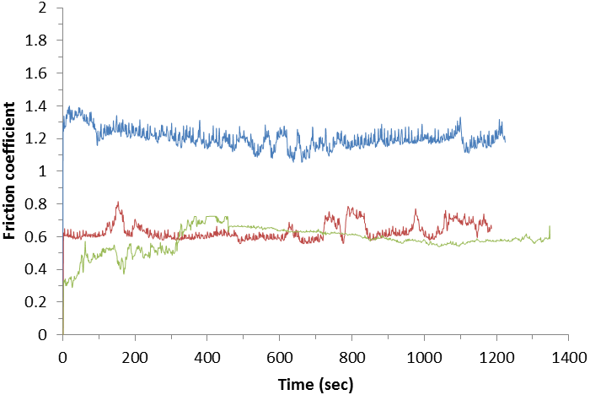
Fig.1 Friction coefficients of various samples when sliding against Ti6Al4V
References
[1] J. van der Geer, J.A.J. Hanraads, R.A. Lupton, The art of writing a scientific article, J. Sci. Commun. 163 (2000) 51-59.
Reference to a book:
[2] W. Strunk Jr., E.B. White, The Elements of Style, third ed., Macmillan, New York, 1979.
Reference to a chapter in an edited book:
[3] G.R. Mettam, L.B. Adams, How to prepare an electronic version of your article, in: B.S. Jones, R.Z. Smith (Eds.), Introduction to the Electronic Age, E-Publishing Inc., New York, 1999, pp. 281-304.
[4] R.J. Ong, J.T. Dawley and P.G. Clem: submitted to Journal of Materials Research. (2003)
[5] P.G. Clem, M. Rodriguez, J.A. Voigt and C.S. Ashley, U.S. Patent 6,231,666. (2001)
[6] Information on http://www.weld.labs.gov.cn

